**Detailed Steps**

**Homework: Using Various HTML Elements on a HTML Page**

**Setup Your Development Environment**

1. On your local machine, open **Notepad++**
2. Go to the **File** menu and select the **Open Folder** option.
3. Create a new folder for all of your homework assignments. > This folder will be used for every homework assignment. Each assignment builds on the previous assignments.
4. *Select* the newly created folder in the dialog.
5. Create a new file name **index.html**. The **index.html** file should now be open in the editor.

*You should now have an environment configured to create HTML web pages. Your editor should have a working folder with only a single file (index.html). This HTML file should be open in your editor.*

**Create a Basic HTML Document**

1. Add the following markup to your file:

<!DOCTYPE html>

1. Below the **DOCTYPE** declaration, add a **HTML** element:
2. <!DOCTYPE html>
3. <html>

</html>

1. Update the opening HTML element by specifying the value **en-US** for the **lang** attribute:
2. <html lang="en-US">

</html>

1. Within the HTML element, add **head** and **body** elements:
2. <html lang="en-US">
3. <head>
4. </head>
5. <body>
6. </body>

</html>

1. Within the head elements, add a **title** element with **Contoso News** as the content of the element:
2. <head>
3. <title>Contoso News</title>

</head>

1. **Save** your HTML file.

*You now have a basic HTML document that has a very clean and concise structure.*

**Add Semantic HTML Elements to The Page**

1. Within the **body** element, add a **main** element between the opening and closing tags:
2. <body>
3. <main>
4. </main>

</body>

1. Within the **main** element, add a **h3** element with the content *Latest Articles*:
2. <main>
3. <h3>Latest Articles</h3>

</main>

1. Below the **h3** element but still within the **main** element, add *three* **article** elements:
2. <main>
3. <h3>Latest Articles</h3>
4. <article>
5. </article>
6. <article>
7. </article>
8. <article>
9. </article>

</main>

1. Within each of the *three* **article** elements, add a **h4** element and an **p** element.
2. <article>
3. <h4></h4>
4. <p></p>

</article>

1. Your HTML should now look like this:
2. <html lang="en-US">
3. <head>
4. <title>Contoso News</title>
5. </head>
6. <body>
7. <main>
8. <h3>Latest Articles</h3>
9. <article>
10. <h4></h4>
11. <p></p>
12. </article>
13. <article>
14. <h4></h4>
15. <p></p>
16. </article>
17. <article>
18. <h4></h4>
19. <p></p>
20. </article>
21. </main>
22. </body>

</html>

1. **Save** your HTML file.

*You now have the basic structure of the articles that will be on your HTML web page.*

**Add Placeholder Text Content**

1. Locate the *first* **article** element within the **main** element. Populate this element's child elements with the following content:
   * **h4:** International Story
   * **p:** Curabitur pharetra luctus augue, non posuere orci tristique vel. Sed posuere nisi nec lacus ullamcorper, ac vulputate nisl consequat. Nullam sollicitudin nulla vel felis faucibus aliquam. Nunc sit amet velit orci. Proin sed orci fringilla, elementum felis condimentum, convallis augue. Aliquam erat volutpat. Mauris tempus nunc sit amet aliquet bibendum. Praesent vestibulum cursus ex, quis laoreet eros consectetur ac. Ut congue libero quis mauris egestas feugiat. Sed pharetra lorem et magna fringilla, a volutpat nibh sollicitudin. Nullam sagittis sollicitudin urna, sed sollicitudin mauris ornare id.
   * <h4>International Story</h4>
   * <p>
   * Curabitur pharetra luctus augue, non posuere orci tristique vel. Sed posuere nisi nec lacus ullamcorper, ac vulputate nisl consequat. Nullam sollicitudin nulla vel felis faucibus aliquam. Nunc sit amet velit orci. Proin sed orci fringilla, elementum felis condimentum, convallis augue. Aliquam erat volutpat. Mauris tempus nunc sit amet aliquet bibendum. Praesent vestibulum cursus ex, quis laoreet eros consectetur ac. Ut congue libero quis mauris egestas feugiat. Sed pharetra lorem et magna fringilla, a volutpat nibh sollicitudin. Nullam sagittis sollicitudin urna, sed sollicitudin mauris ornare id.

</p>

1. After the last line of text within the **p** element of the *first* **article** element, add a hyperlink (**a**) element with the following attributes:
   * **content:** Read More...
   * **href:** #
   * **target:** _blank
   * <article>
   * <h4>International Story</h4>
   * <p>
   * Curabitur pharetra luctus augue, non posuere orci tristique vel. Sed posuere nisi nec lacus ullamcorper, ac vulputate nisl consequat. Nullam sollicitudin nulla vel felis faucibus aliquam. Nunc sit amet velit orci. Proin sed orci fringilla, elementum felis condimentum, convallis augue. Aliquam erat volutpat. Mauris tempus nunc sit amet aliquet bibendum. Praesent vestibulum cursus ex, quis laoreet eros consectetur ac. Ut congue libero quis mauris egestas feugiat. Sed pharetra lorem et magna fringilla, a volutpat nibh sollicitudin. Nullam sagittis sollicitudin urna, sed sollicitudin mauris ornare id.
   * <a href="#" target="_blank">Read More...</a>
   * </p>

</article>

1. Locate the *second* **article** element within the **main** element. Populate this element's child elements with the following content:
   * **h4:** Finance Story
   * **p:** Nullam tempor mi at libero elementum varius. Sed lobortis lacus feugiat est tristique, nec imperdiet turpis scelerisque. Ut sed urna malesuada, scelerisque dui sit amet, tempus mauris. Integer bibendum egestas urna, a bibendum sem gravida quis. Cras accumsan rhoncus vestibulum. Nam eu blandit leo. Integer at consectetur nunc, et tempus urna. Integer sit amet sollicitudin elit. Donec nec posuere erat. Sed vestibulum nisl neque, vitae tincidunt ex molestie quis. Nulla fringilla viverra turpis in volutpat. Cras vel orci quis velit efficitur ullamcorper sed eu ex. Nullam vel ex nec lectus imperdiet luctus vitae vel nibh. Donec eleifend velit eros, eu efficitur justo molestie id. In egestas gravida lectus. Ut ipsum odio, suscipit sit amet molestie non, scelerisque sed mi. Aenean sed augue eu arcu faucibus molestie. Sed eget ante gravida, rhoncus velit eu, tempus quam. Sed fermentum at odio sed commodo. Fusce lobortis cursus purus, quis consequat est faucibus at. Etiam massa felis, sodales at sodales sed, iaculis quis arcu.
   * <h4>Finance Story</h4>
   * <p>
   * Nullam tempor mi at libero elementum varius. Sed lobortis lacus feugiat est tristique, nec imperdiet turpis scelerisque. Ut sed urna malesuada, scelerisque dui sit amet, tempus mauris. Integer bibendum egestas urna, a bibendum sem gravida quis. Cras accumsan rhoncus vestibulum. Nam eu blandit leo. Integer at consectetur nunc, et tempus urna. Integer sit amet sollicitudin elit. Donec nec posuere erat. Sed vestibulum nisl neque, vitae tincidunt ex molestie quis. Nulla fringilla viverra turpis in volutpat. Cras vel orci quis velit efficitur ullamcorper sed eu ex.
   * Nullam vel ex nec lectus imperdiet luctus vitae vel nibh. Donec eleifend velit eros, eu efficitur justo molestie id. In egestas gravida lectus. Ut ipsum odio, suscipit sit amet molestie non, scelerisque sed mi. Aenean sed augue eu arcu faucibus molestie. Sed eget ante gravida, rhoncus velit eu, tempus quam. Sed fermentum at odio sed commodo. Fusce lobortis cursus purus, quis consequat est faucibus at. Etiam massa felis, sodales at sodales sed, iaculis quis arcu.

</p>

1. After the last line of text within the **p** element of the *second* **article** element, add a hyperlink (**a**) element with the following attributes:
   * **content:** Read More...
   * **href:** #
   * **target:** _blank
   * <article>
   * <h4>Finance Story</h4>
   * <p>
   * Nullam tempor mi at libero elementum varius. Sed lobortis lacus feugiat est tristique, nec imperdiet turpis scelerisque. Ut sed urna malesuada, scelerisque dui sit amet, tempus mauris. Integer bibendum egestas urna, a bibendum sem gravida quis. Cras accumsan rhoncus vestibulum. Nam eu blandit leo. Integer at consectetur nunc, et tempus urna. Integer sit amet sollicitudin elit. Donec nec posuere erat. Sed vestibulum nisl neque, vitae tincidunt ex molestie quis. Nulla fringilla viverra turpis in volutpat. Cras vel orci quis velit efficitur ullamcorper sed eu ex.
   * Nullam vel ex nec lectus imperdiet luctus vitae vel nibh. Donec eleifend velit eros, eu efficitur justo molestie id. In egestas gravida lectus. Ut ipsum odio, suscipit sit amet molestie non, scelerisque sed mi. Aenean sed augue eu arcu faucibus molestie. Sed eget ante gravida, rhoncus velit eu, tempus quam. Sed fermentum at odio sed commodo. Fusce lobortis cursus purus, quis consequat est faucibus at. Etiam massa felis, sodales at sodales sed, iaculis quis arcu.
   * <a href="#" target="_blank">Read More...</a>
   * </p>

</article>

1. Locate the *third* **article** element within the **main** element. Populate this element's child elements with the following content:
   * **h4:** Technology Story
   * **p:** Morbi eget justo ut velit dapibus malesuada. Nunc elementum, neque quis convallis tempus, lacus ante tristique est, id porta tortor leo eget orci. Suspendisse hendrerit interdum lacus et condimentum. Mauris at ex dignissim, bibendum libero at, fermentum lectus. Maecenas porttitor purus quis augue interdum, eget malesuada neque placerat. Ut hendrerit risus in nibh elementum, quis vestibulum ipsum vulputate. Nulla facilisi. In consectetur et lacus vel tincidunt. Quisque feugiat ipsum et erat rhoncus efficitur. In in augue at enim tempor sollicitudin.
   * <h4>Technology Story</h4>
   * <p>
   * Morbi eget justo ut velit dapibus malesuada. Nunc elementum, neque quis convallis tempus, lacus ante tristique est, id porta tortor leo eget orci. Suspendisse hendrerit interdum lacus et condimentum. Mauris at ex dignissim, bibendum libero at, fermentum lectus. Maecenas porttitor purus quis augue interdum, eget malesuada neque placerat. Ut hendrerit risus in nibh elementum, quis vestibulum ipsum vulputate. Nulla facilisi. In consectetur et lacus vel tincidunt. Quisque feugiat ipsum et erat rhoncus efficitur. In in augue at enim tempor sollicitudin.

</p>

1. After the last line of text within the **p** element of the *third* **article** element, add a hyperlink (**a**) element with the following attributes:
   * **content:** Read More...
   * **href:** #
   * **target:** _blank
   * <article>
   * <h4>Technology Story</h4>
   * <p>
   * Morbi eget justo ut velit dapibus malesuada. Nunc elementum, neque quis convallis tempus, lacus ante tristique est, id porta tortor leo eget orci. Suspendisse hendrerit interdum lacus et condimentum. Mauris at ex dignissim, bibendum libero at, fermentum lectus. Maecenas porttitor purus quis augue interdum, eget malesuada neque placerat. Ut hendrerit risus in nibh elementum, quis vestibulum ipsum vulputate. Nulla facilisi. In consectetur et lacus vel tincidunt. Quisque feugiat ipsum et erat rhoncus efficitur. In in augue at enim tempor sollicitudin.
   * <a href="#" target="_blank">Read More...</a>
   * </p>

</article>

1. **Save** your HTML file.

*You now have populated your HTML web page with lorem ipsum content. This content is intentionally designed to be hard to read so that reviewers would focus on the appearance and layout of your web page as opposed to the text and copy.*

**Add a Header Element**

1. Within the **body** element of your HTML document, add a new **header** immediately prior to the **main** element:
2. <body>
3. <header>
4. </header>
5. <main>
6. ...
7. </main>

</body>

1. Within the new **header** element, add a **h1** element:
2. <header>
3. <h1></h1>

</header>

1. Update the **h1** element by setting it's content to *Contoso News*:

<h1>Contoso News</h1>

1. Within the new **header** element, add a **h2** element:
2. <header>
3. <h1>Contoso News</h1>
4. <h2></h2>

</header>

1. Update the **h2** element by setting it's content to *On Time, On Topic*:

<h2>On Time, On Topic</h2>

*You now have a header element on your web page using two heading elements for it's text content.*

**Validate**

1. Open it in your favorite **WEB Browser**  to view the resulting web page.
2. Observe the HTML web page.
3. Does your solution look similar to this? 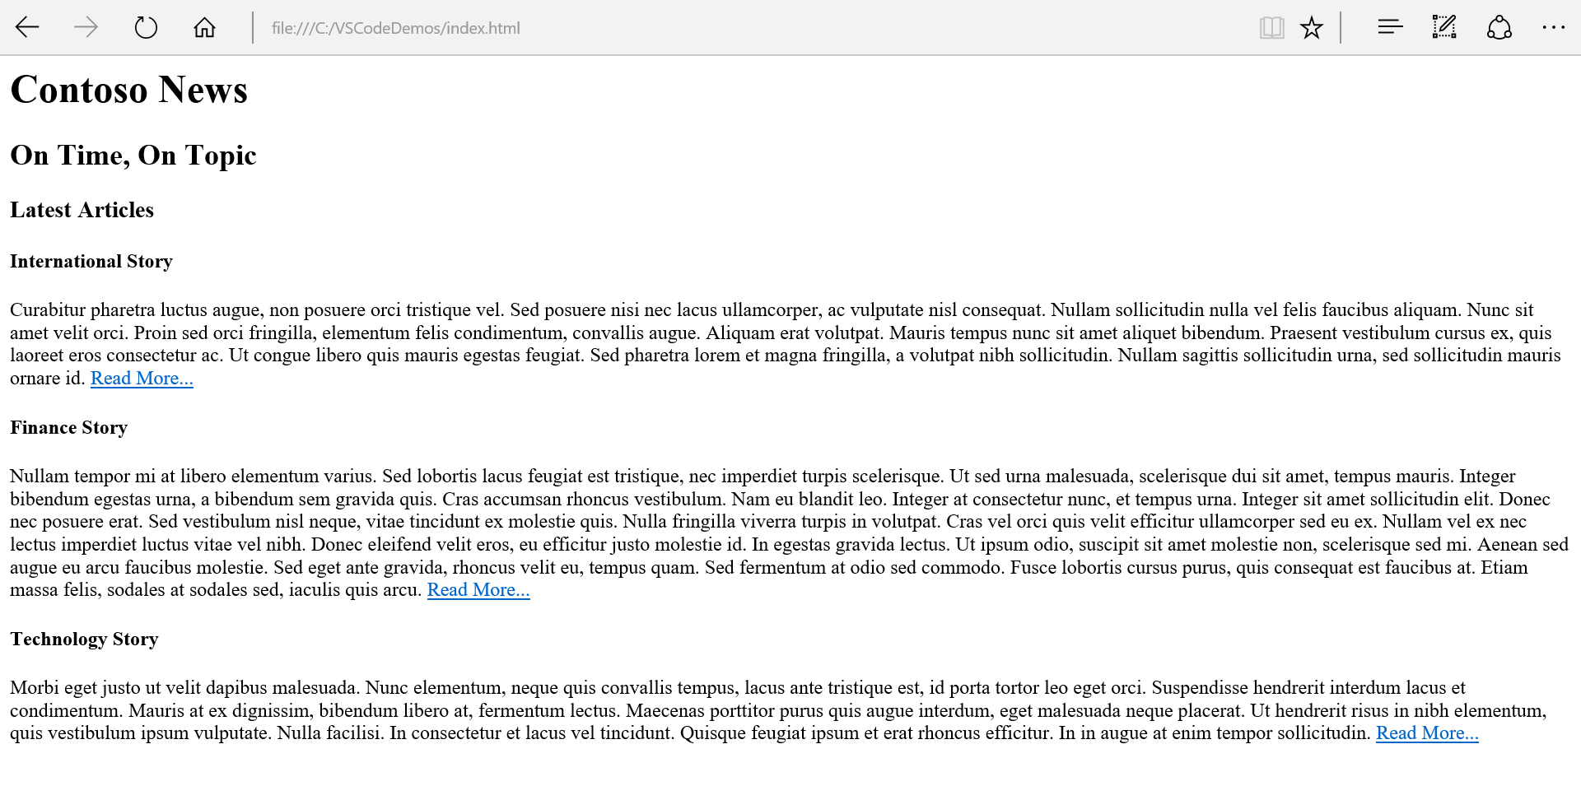
4. Close your open browser and **Visual Studio Code**.

*Remember to save your files. The next homework assignment will resume from this web page.*